Spen Valley’s Forgotten History
The mineral railways of yesteryear
One aspect of economic activity in Spen Valley you’ll struggle to find a great deal about is coal mining. There’s an even thinner historic record of the miles of railways that connected over 30 coal mines from the mid 19th and into the early 20th centuries.
This feature article explains what these coal railways, or tramways, were, where they were and what remains can be seen today.
-o0o-
There have been coal mines of various sorts all over Spen Valley. Dozens of them. Everywhere. Not all at once and many of them very shallow, but mines, collieries or pits all the same.
But one group of mines were different. They were owned by either the Bowling or the Low Moor Iron Companies and many of them were connected by “railways”.
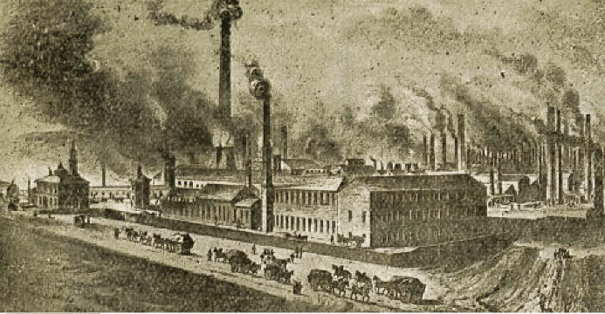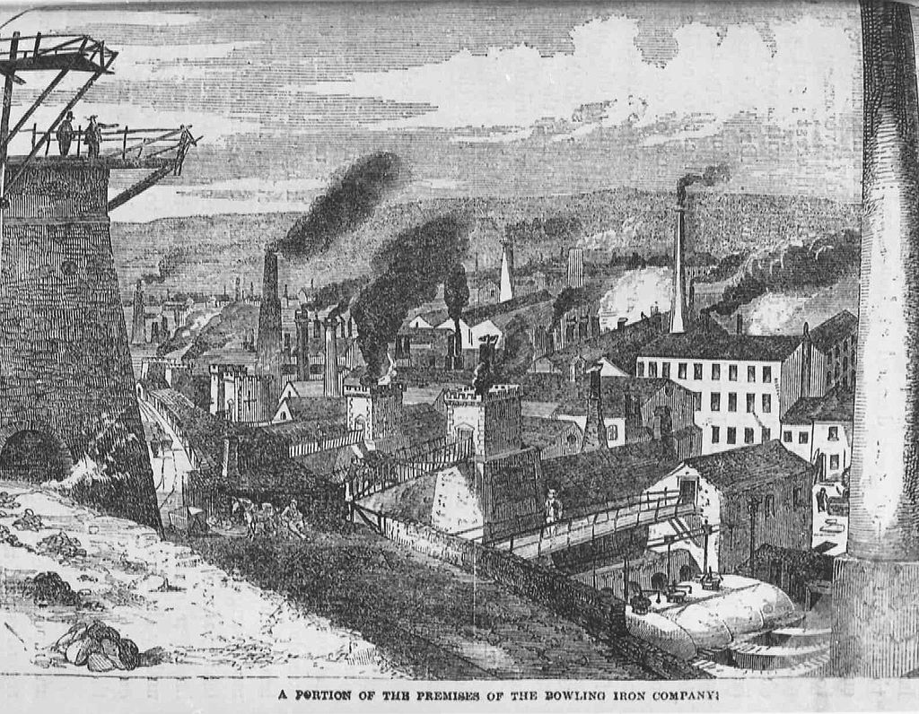
Low Moor Ironworks in the mid C19th Bowling Ironworks at the same time
These companies exploited the coal seams beneath Hartshead, beneath the Kirklees estate, beneath Clifton, Hartshead Moor, Scholes, Wyke, Oakenshaw, Hunsworth and East Bierley. It comes as a surprise that places such as East Bierley and Hartshead were, for a while, pit villages.
So how did this come about?
From the start of the industrial revolution the need for coal expanded hugely. Wherever coal existed, someone was digging it up. The two iron companies had a terrific thirst for coal, an essential material for making iron. To expand the supply of coal they decided to go into coal mining. East Bierley and Hunsworth pits supplied Bowling and the rest supported Low Moor.
In other parts of the UK and in particular the Durham and Newcastle areas, coal was mined for export to the cities, in particular London. This could only happen once coal was put on rail tracks, because to move coal by horse and cart was hopelessly uneconomic after a few miles. So at first rails were laid and horses pulled coal wagons along the rails. This made it economic to move the coal all the way to a harbour.
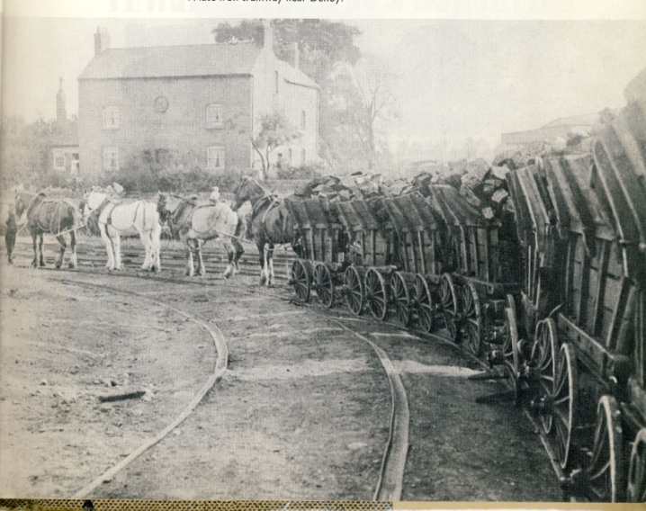 A team of horses pulling coal wagons, or corves as they were called. If you look carefully the wagon wheels run outside the upstand on the rail, indicating these are the easily broken cast iron rails.
Obviously this is later than the invention of photography, but just goes to show that not everywhere converted to horse and then to steam at the same time. But everywhere, laying rails was the answer and when these became made from wrought iron instead of cast iron, they stopped breaking under the weight.
But very soon the first travelling steam engines were replacing horses.
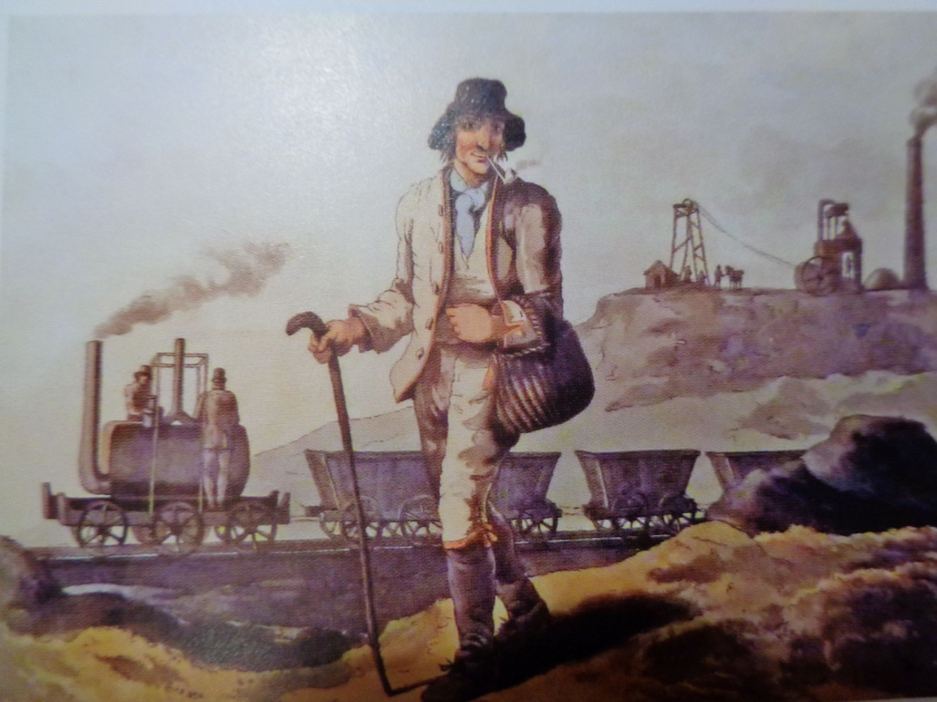 A scene at Middleton Colliery Leeds around 1814; note the very early Blenkinsop steam engine

Back in the Spen Valley, it seems the Bowling managed pits were the first to be connected by these railways. And indeed they were pulled by horses, at least at first. The coal wagons or corves were hauled up to Toftshaw. Part of the route is known as “Eight Horse Incline”, which is a bit of a give- away as to what provided the muscle.
Until the 1970s the locations of all these pits could be seen as all were marked by a small hill, comprised of waste shale. But when the M62 was built some were taken away. Some surviving ones were carted off by the county council for covering refuse at landfill sites, such as at Wilson Road, Wyke and Nab Lane, Birstall. But the discerning eye can still make out some of the locations.
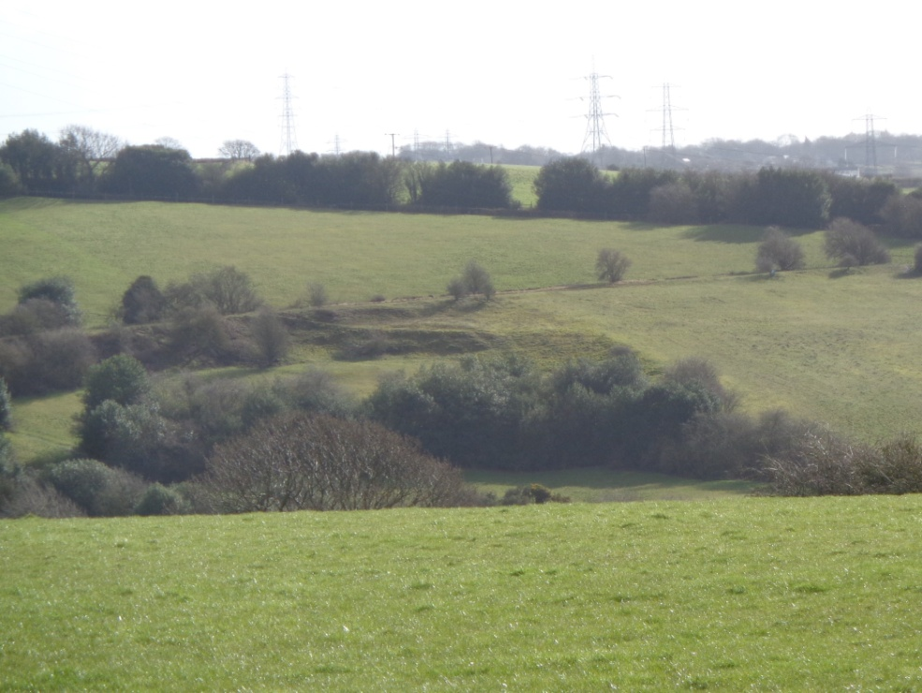 Here is a photo of the gradient down to Toftshaw Bottom, known as Eight Horse Incline. From the right down to the left.
-o0o-
Across the valley a network of railways and pits was developed to supply Low Moor Ironworks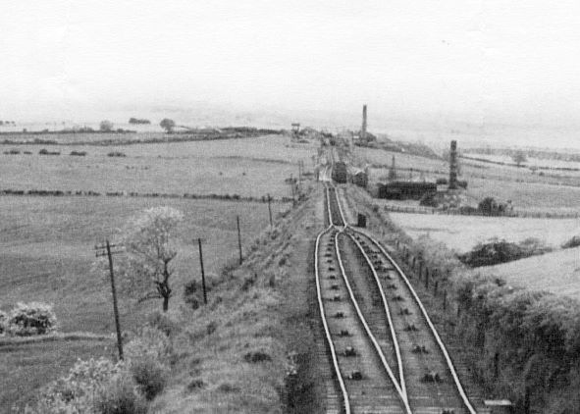 This photo shows part of the Hetton Colliery railway in the north east, with cables down the middle and a passing place. This is a dead ringer for what much of the Low Moor system would have looked like, but, astonishingly, no photographs have survived, if ever there were any.
Again, most of the pit head spoil heaps were taken away for the M62. However a small one remains and can be seen in the field to the north of the road from Hartshead Moor to Clifton. There’s another close by Whitaker Pits Wood, close by Hartshead Moor Top. Some cuttings were also filled in, for example the one from Highmoor Lane pit north to Whitaker pit.
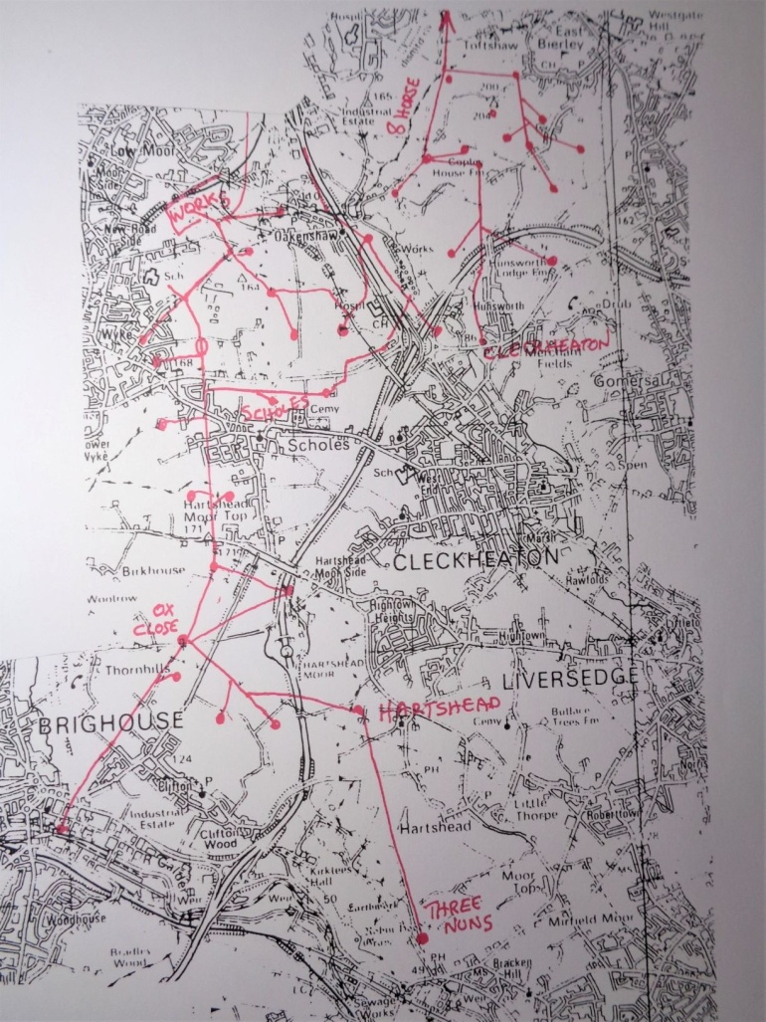 This very simplified map shows the connected pits on the east side of the valley and also west of Spen Beck. There were a few more around Wyke and to the north of Low Moor. As can be seen the most distant pit was near Cooper Bridge. In fact it was not far behind the Three Nuns pub.
It is (again) believed that horses were used initially, but this did not evolve into using travelling steam engines. Instead the company employed its own system of power based on static steam engines, pulling coal wagons up and down the tracks using a system of cables and pulleys. This system had already been used at other pits in the north east.
The railway system in Hartshead, Clifton and Scholes arrived via a crossing of Whitehall Road and ran due south to Ox Pit in Jay House Lane. The low mound opposite Grasmere Avenue in Scholes is where the railway crossed Whitehall Road. 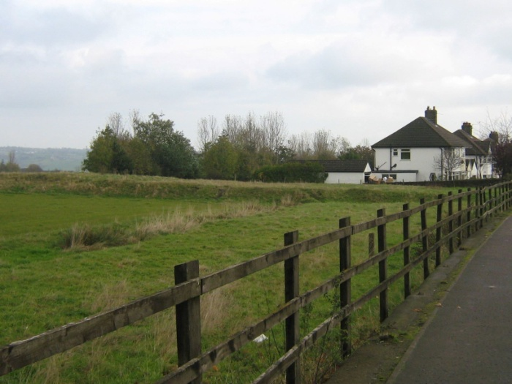
Ox Pit and the adjacent mine owned houses of Ox Close was the hub of the system, receiving coal from local pits and sending it north. Eight more pits connected from the east and west in the Scholes area, such as Chairbarrows Pit. Five engine houses provided the power for pulling the coal wagons uphill and restraining their descent.
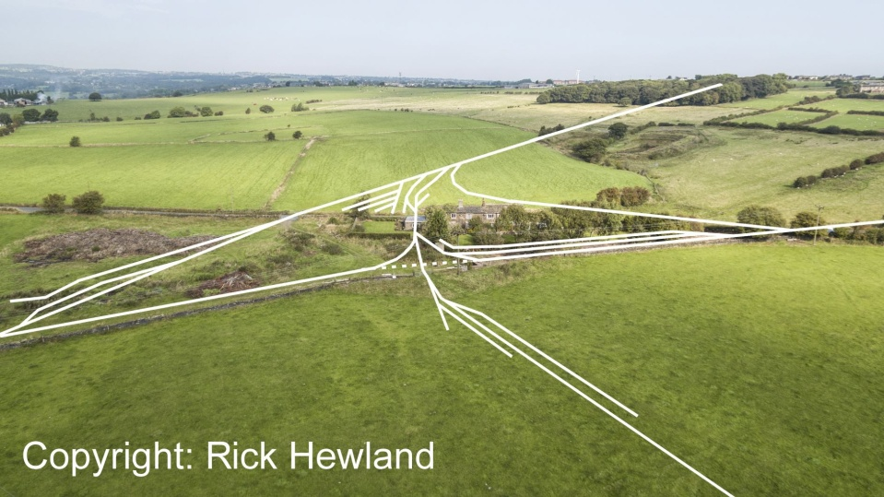
Ox Pit in Jay House Lane was the local hub for the local coal lines. These white lines superimposed on a 2016 drone photograph show the extent of lines concerned. Top right shows the line going through Whitaker Pits wood.
Once north of Whitehall Road the loaded wagons entered sidings at Cow Close Lane where a travelling steam engine, or train, picked up the wagons and took them into the works.
For a while some coal was sent to Brighouse gasworks. An engine near the top of Clifton Common with a brake drum lowered the full wagons down the hillside with the downhill weight drawing up the empties fastened to the same cable.
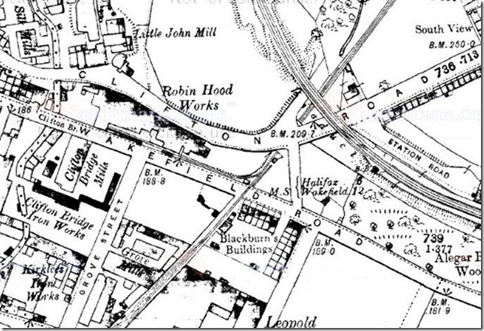
This old map extract shows the cables and wagons actually crossed over Wakefield Road,(not under) so there must have been a guard to hold up any traffic as the wagons passed.
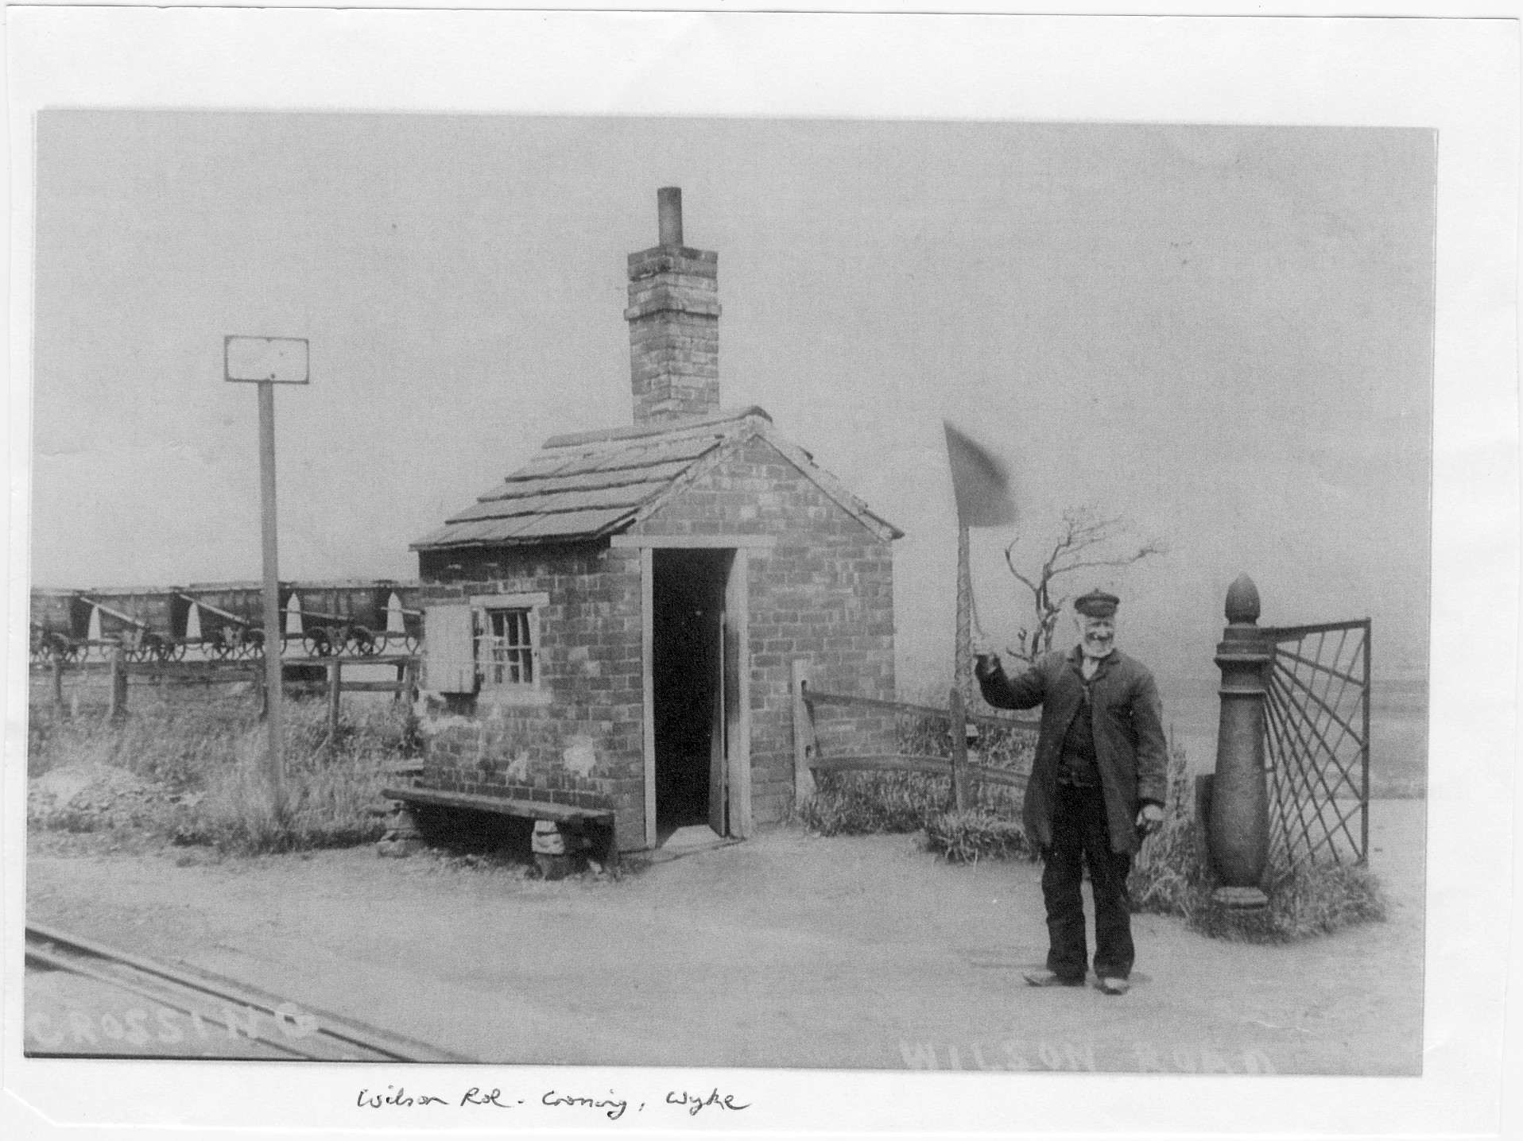This C
This chap is at the crossing of a line with Wilson Road in Wyke; you can see some corves in the background. This scene would be repeated across the district.
So what is there left to see? Well, perhaps the strongest feature is the embankment from Ox Pit, heading off toward Brighouse.
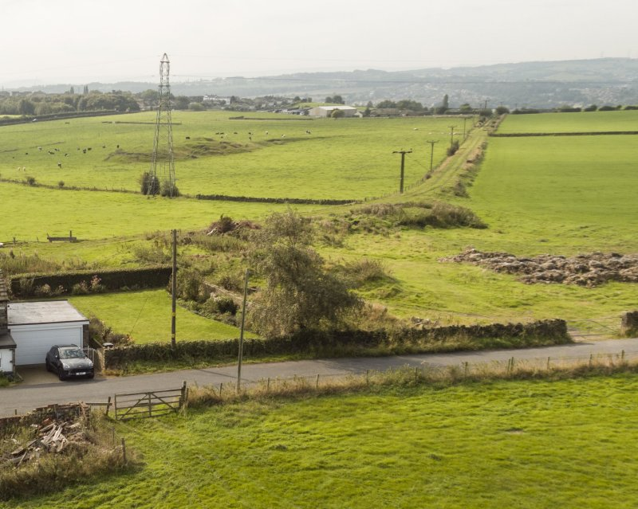
In this drone enabled photo in Jay House Lane the line toward Brighouse is clearly seen. Ox Pit occupied the rough ground on the right. Behind the pylon is the mound belonging to Clifton Colliery. Just visible in the bottom left is the remains of the equipment repair building.
Also to be seen is the cutting off Freakfield Lane at Hartshead, now lined with trees, heading off toward Cooper Bridge. There’s also the underpass at the top of Birkby Lane where the railway passed beneath Halifax Road.

The tunnel at the top of Birkby Lane which carried the line toward Scholes. 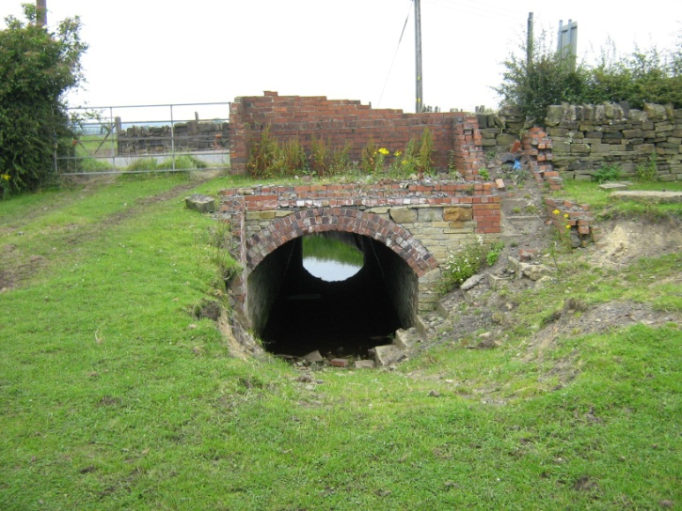
Once you have a map of where the lines were laid, then a ramble around the fields will identify many more tell tale remains to the discerning eye.
By 1851 Low Moor had over 50 pits with 22 miles of track above ground and over 70 miles underground. By 1863 the company employed 1993 miners at some 70 pits.
In the years after 1842 children under 12 could no longer work in the mines, but there were many boys age 10 and over. Two boys fell down the shaft at Hartshead Pit (then called Soaphouse) in 1863.
The 1861-91 census returns for Jay House Lane and The Clough give an idea of the dependency on coal mining. Jobs listed for the residents included; colliery waggoner, coal miner, coal leader, colliery labourer, lamp cleaner, hanger at coal mine, coal deputy, horse waggoner, horse teamer, colliery steward, engine stoker, coal screener and colliery banksman (pit head overseer).;
There were also at least 10 pits between Wyke, Scholes and Oakenshaw. Royd Pit on today’s golf course was linked across Whitehall Road to Wavell Pit behind the Whitechapel Road cemetery.
Half a mile south of Oakenshaw the Spen Valley Greenway crosses over a substantial bridge, with nothing underneath, no stream, no path, no track. But take a look at the 1891 map and a coal tramway went through that underpas. So it looks like the Low Moor Iron Company was able to force the Lancashire and Yorkshire Railway Co to provide the underpass when the mainline was built in 1848, in anticipation of it being required for a tramway. Which indeed seems to have been the case.
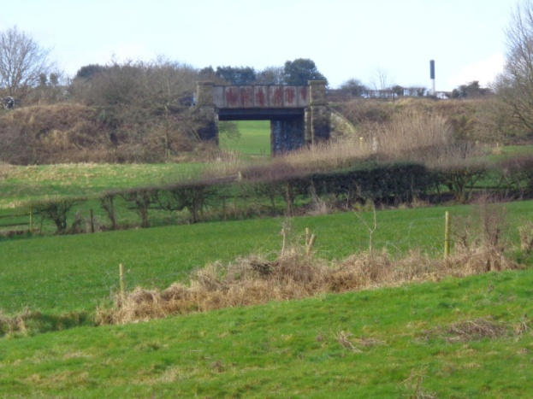 The

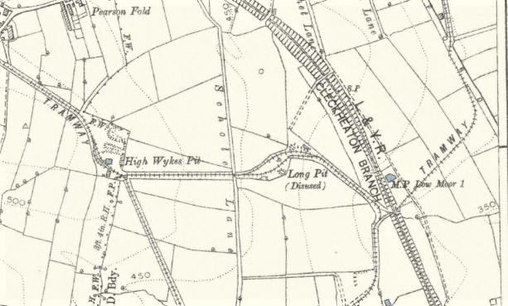
Photo
Top photo shows the mysterious underpass on the Greenway, whilst the lower map from the 1889 survey shows an Oakenshaw tramway passing through to the pits to the west.
-o0o-
Some of the pits only lasted a few years, but several were worked over 50, 60 and 70 years. Scholes opened in 1855 in Branch Road and Hartshead was the last to close in 1935, seven years after the Low Moor Co. went bust.
There are a few other physical remains, such as an old cable roller found near Hartshead and a few rail sleeper padstones being used as a copings in field walls. But that’s about it.
